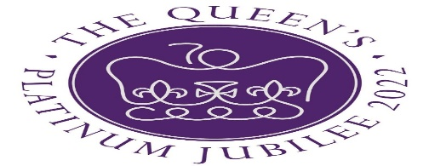
Please join us on
Saturday 4 June 12pm -4pm
at the recreation ground
to celebrate the Queen’s Platinum Jubilee

We will be 'unveiling' the 5 oak trees at 1pm
Bring a picnic
The cricket club bar will be open

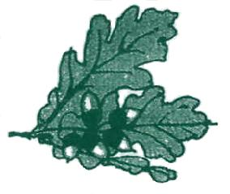
Capel Parish Council Office
Capel Village Hall
Five Oak Green
Kent TN12 6RD

Tel: (01892) 837524

