HIP Front Cover
HIP Version | Submitted by (Name) |  | HIP Date |  | Record Of Meeting Dates with KCC Virtual or Face to Face |  |  |  | Please list below the funding Opportunities/Sources for HIP initiatives/Measures
6 | Louise Goldsmith |  | 22.04.2024 |  | 18.01.2023 (virtual)  11.05.2023 (on site)  22.04.2024 (on site) |  |  |  | County Member, Parish Precept Donation, LTP bid
Are you an active member of the Speed Watch Scheme? |  |  |  | Yes ☒  No ☐ |  |  | Are you an active member of the Lorry Watch Scheme? |  |  |  |  | Yes ☐  No ☒
Name of HIP Representative |  | Louise Goldsmith |  |  |  | Contact Telephone Number |  | 01892 837524  07508 882810 |  | Email Address | clerk@capel-pc.org.uk
Name of Clerk |  | Louise Goldsmith |  |  |  | Contact Telephone Number |  | 01892 837524  07508 882810 |  | Email Address | clerk@capel-pc.org.uk
Name of Chair |  | Hugh Patterson |  |  |  | Contact Telephone Number |  | 01892 837201  07913 899563 |  | Email Address | hughpatterson@capel-pc.org.uk
KCC Project Manager Name |  | West Kent Highway Improvement Team |  |  |  | Contact Telephone Number |  | 03000 418181 |  | Email Address | west.highwayimprovements@kent.gov.uk
- Please note the Priority column MUST be those issues which are regarded as the most important (No 1 being your highest priority, then filtering down) KCC is unable to guarantee that all your requests will be deliverable, but Project Managers can investigate your top 1 or 2 priorities per year.
Live Priorities Record
Priority |  | Location | Problem/Concern | What do you feel are the potential solutions? |  | KCC Comments (This column is to be completed by Project Manager ONLY)
1. |  | West and East entrances to Five Oak Green. B2017 Five Oak Green Road | Speed and volume of traffic. | Implementation of chicane features to slow vehicles on entry to the village, including the necessary signage;  Dropped kerb, tactile paving crossing implemented on chicane to the east of Sychem Lane to provide a formal crossing location;  Enhanced signage, clearly outlining the speed limit within the village;  The provision of red surfacing to reinforce the sign posted speed limit;  The provision of a low kerb line to delineate the parking area within the vicinity of the Post Office, narrowing the main carriageway in this location to promote a lower speed environment;  Declassification of the B2017 |  | Pre-2023 - No traffic calming because this road is a B Road – before we consider any improvements here, we would advise an ATCs to be carried out before any type of engineering is looked into for the concern.  ATC  Whetsted Road  Falmouth  By school  Email 11.07.22 - Sarah Hamilton suggesting perhaps a bend warning sign – Feedback as a whole once ATCs are back.  18.01.23 - Parish Council has been provided with the following ATC results:  Whetsted Road – average speeds between 24-27mph (85% 29-32mph)  Five Oak Green Road (30mph) - average speeds between 32-33mph (85% 38/39mph)  Parish Council has concerns regarding the number of near misses and children being hit. There are no/ narrow footways along Whetsted bridge to Five Oak Green jct with Oak Road.  Main concern is around the Whetsted Road jct with Five Oak Green Road, towards Primary School, due to speeding and rat running from Five Oak Green.  ET to look into the possibility of installing chicanes and to review the report from 2018 identifying possible safety measures.  The Parish is looking to get some section 106 money so needs an improvement scheme to assist with funding.  01.02.23 - With regard to installing physical traffic calming, this is not possible. It is not appropriate on A or B class roads (or those classified as direct distributors), as these are routes that the emergency services would expect to be kept clear and would also have, by definition, high flows of buses and commercial vehicles. They should be accessible by all modes of transport to ensure they can reach their destination without using alternative routes that may be less suitable.  The Parish Council highlighted the chicanes on the A25, High Street through Brastead, however these predate 2008 and likely our agreement with the emergency services. They would not be installed under today’s guidelines.  It is noted on pg 13 of the Strategy for Five Oak Green that it states: The B2017, which runs through the centre of Five Oak Green, has a ‘B’ road classification. As a result of this, and in accordance with KCC guidance, no vertical deflections (e.g. speed humps or raised tables) can be implemented on this road. Given the above, horizontal deflections in the form of chicanes are considered to be the most appropriate solution.  However, there is no differentiation between vertical and horizontal deflections as horizontal deflections sill impede drivers and we would not install these on A or B roads.  The trigger point to highlight a speeding problem is the average/mean speed being above the enforcement threshold. The ATC for Five Oak Green Road shows average speeds below the enforcement threshold of 35mph at 32.5mph so there is acceptable compliance with the limit.  However, ET has asked Planning & Advice (ref. 12409014) to review the independent survey provided by the Parish and provide comments on the recommendations as well as the Parish's proposed solutions. These include dropped kerb, tactile paving crossing implemented on chicane to the east of Sychem Lane to provide a formal crossing location; Enhanced signage, clearly outlining the speed limit within the village; The provision of red surfacing to reinforce the sign posted speed limit; The provision of a low kerb line to delineate the parking area within the vicinity of the Post Office, narrowing the main carriageway in this location to promote a lower speed environment; Declassification of the B2017.  17.02.23 - Response from Planning & Advice received as follows: The ATC shows an avg speed of 32.48 which falls within the threshold so there is in general a good compliance for the speed limit. HADMS data shows only 1 speed related damage only and no injury collisions relating to speeding. Speed limit is 30mph and there is a series of street lighting so no further 30 signs can be installed due to legislation. Red surfacing also would not be practical as there is no trend of speeding or accidents relating to the speed limit so this would not make any difference.  Kerb line around post office is fine but the lining for the parking places could be refreshed. If we lowered the kerb line, then we may find vehicles mounting the kerb causing a new safety issue for pedestrians etc. We would not look to narrow the carriageway due to there being no crash history to warrant this and any highway intervention would be deemed not necessary at this location.  In regard to the crossing point on Five Oak Green Road (east of Sychem Place), can the Parish Council advise where they would like this installed (i.e. where is the desire line and footfall; where are most people already crossing the road and what are the journey generators?) so that we can determine the best place for a crossing to be installed if possible. There are multiple drops along this stretch for driveways where users can cross, albeit no formal crossing point, so if we can determine where this is most needed, we can see if it is practical to install a crossing point. (03.04.23 - S278 works are being carried out outside Capel Primary school, Five Oak Green Road, junction with Church Lane which includes changes to the footway as well as two sets of dropped kerbs with tactile paving to create informal crossing points.) ET offered a site visit to discuss location of crossing in more detail 25.04.23.  13.03.23 - ET suggested possible SID location along Whetsted Road and Five Oak Green Road - see comments under Priority 2 ‘Vicinity of Capel Primary School, Five Oak Green Road, Five Oak Green’.  26.04.23 - ET meeting with Capel PC 11.05.23 to discuss crossing on site.  12.05.23 - On site, the Parish Council and KCC discussed the possibility of installing a zebra crossing on Five Oak Green Road, near to the junction with Sychem Lane. ET is discussing with Planning & Advice w/c 15.05.23 and will update Capel PC following this.  19.05.23 - Enquiry raised with Planning & Advice (reference 12409353) to review and comment on the feasibility of a zebra crossing being installed on Five Oak Green Road, near to the junction with Sychem Lane. This request is also supported by Capel Primary School.  16.06.23 - Planning & Advice has completed their review of this request and they believe that it would be feasible to install a zebra crossing at this location, with the recommendation that any vegetation is cut back to ensure the full width of the footway is available for any pedestrians approaching the crossing, Street Lighting to be informed to ensure there is sufficient lighting around and on the crossing and drainage to be checked as any pooling of water will create a hazard to pedestrians with the potential of vehicles losing control or skidding. Passed to Design & Delivery to advise on next steps.  Design & Delivery confirmed that pedestrian and traffic surveys will need to be carried out in the first instance in order to calculate the ‘PV2 value’, which will determine if a zebra crossing is appropriate for this location.  28.06.23 - ET emailed Parish Council to confirm that they are happy for KCC to arrange the necessary surveys at the location previously agreed:  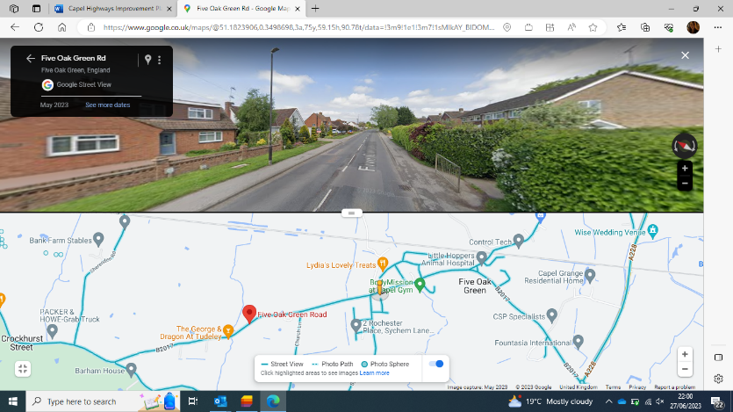  29.06.23 - The Parish Council confirmed the location for the ATC and Ped survey, and a request has been sent to the survey company. ET to update the Parish Council when dates for the surveys have been arranged.  30.06.23 - ATC and Ped surveys have been arranged to start from 8 July. The £1080 cost for these surveys will be funded by KCC. Parish Council informed.  31.07.23 - ATC and Ped survey results have been received (outlined below) and these have been shared with the Parish Council and Planning & Advice (under the original reference 12409353) for comment.  Speed survey:  East – av. speed 31mph (85% 36.1mph)  West – av. Speed 31.8mph (85% 36.6mph)  Ped survey (total across 7 days):  Eastbound - 274 pedestrians  Westbound - 242 pedestrians  25.08.23 - Planning & Advice (P&A) have completed their review of the suitability of this location for a zebra crossing which includes calculating the PV2. This is used as part of all crossing assessments and assesses the level of conflict between pedestrian (P) and vehicles (V) at a given location. This PV2 at this location is 4,720,641 (needs to be over 100,000,000).  P&A went one step further and conducted what is called a ADPV2. This is a more recent modification to the PV2 formula which takes into account the number of Accidents (A) over the last three years and the difficulty (D) level of crossing the road at a given point:  (A) - Recent pedestrian injury collisions over the last three years – none at this location  (D) – Difficulty crossing at said location which is influenced by its road width, speed of traffic and number of lanes being crossed and is calculated as a comparison with the standard 7.3m urban 30mph road.  ADPV2 = 3,351,655 (needs to be over 20,000,000 for a crossing to be justified).  With the above in mind there currently is not a requirement for a crossing at this location.  However, following a site visit on 04.08.23 to look at potential alternative options, we would be happy to consider a system of traffic calming (minimum of two) in the form of chicanes/ kerb buildouts which would assist with crossing the road, in the absence of a zebra crossing, as it could be built out to the centre line with a dropped kerb and tactile paving. This would also assist with reducing traffic speeds and we could look to install one by Sychem Lane and one closer to the school.  This would be a £50k+ scheme so would either need developer contributions if the planning application for 140 houses in the field near to the school goes through or an LTP bid but ET is happy to pursue both options if this proposal is amendable to the Parish Council.  29.08.23 - Parish Council confirmed that they would like to move forward with the suggested scheme.  ET asked Parish Council to confirm what they think about the number and location of the chicanes proposed. Two suggested; one by Sychem Lane, near to where we looked at for the zebra crossing, and one closer to the school (pending a thorough review by Design & Delivery).  In the meantime, this has been added to the list for LTP bidding in the Autumn. Should this scheme be successful, it will be delivered in the 2024/25 financial year. ET will let the Parish Council know the outcome of the bid later in 2023.  03.10.23 - At the Parish Council meeting held on the 25 September 2023 Members resolved to request that KCC applies for funding from the Local Transport Plan Funding to install a system of traffic calming (minimum of two) in the form of chicanes/ kerb buildouts, with one to be by Sychem Lane, and one closer to the school. Members were in agreement that it would be beneficial to have the chicanes/kerb buildouts at each end of the village and have asked if this suggestion could also be included in the application for funding. ET to take forward.  24.11.23 - ET informed the Parish Council that, out of the seven schemes that were put forward for possible LTP funding, only four will be going on to ‘Dragons Den’, with funding likely available for just two.  Unfortunately, Five Oak Green was not one of the four schemes chosen to proceed further.  However, ET is looking to proceed with a smaller scale scheme, which will be funded from KCC’s small works budget and seeks to offer more protection up by the Primary School.  The small works scheme will include, in the first instance, upgrading the existing school wig wags to Smart pulsas, improving the visibility of the school warning signage and complimenting these with SLOW markings on the carriageway (ordered 12.12.23). Once the existing manual wig wags are upgraded, they will be programmable and we will take care of this so that the school don’t need to be involved. This will result in an advisory 20 past the school during peak times and we have found this to be very effective in other locations.  In addition, we are also starting to look at other measures that can be introduced in the new financial year including an informal crossing, highlighted by dropped kerbs with tactile paving, near to the school and within what will be the advisory 20mph, to assist with school children crossing the road. Proposed locations below (passed to Planning & Advice to confirm suitability 08.12.23):  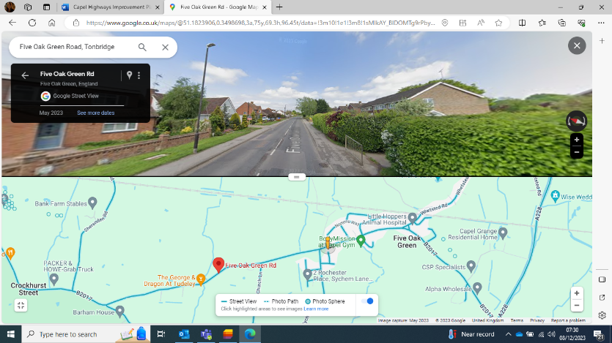  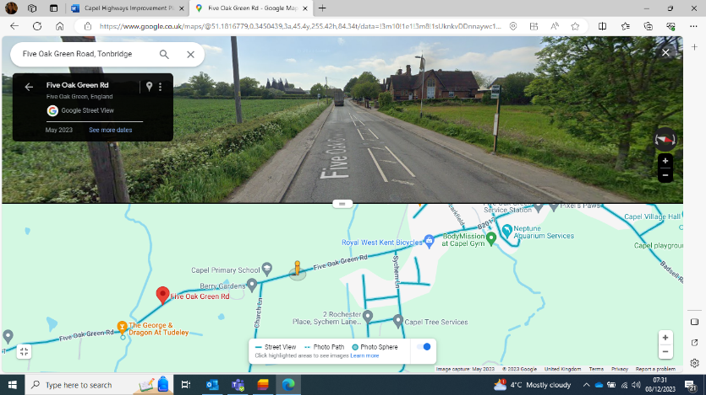  With the proposed small works scheme, along with installation of the SIDs from Badsell Road and along Five Oak Green Road, ET is hopeful that we will see speeds improve through the village, and more specifically past the school. KCC’s proposal is to monitor speeds again six months after the two schemes have been implemented and then we can revisit the situation and whether there are any further concerns at this location.  22.12.23 - The Planning & Advice Team has no objection in principle to these two proposals and would therefore be happy to support dropped kerbs here. Visibility appears suitable. Precise locations will need to be determined at detailed design stage, to minimise conflict with the bus stops and drainage etc. ET passed to Design & Delivery.  15.04.24 - Work to install two pairs of dropped kerbs has been ordered. Design shared with the Parish Council 16.04.24.  22.04.24 - During the site visit, the Parish Council raised concerns that the western dropped kerbs (location 1 on the scheme drawing) will be parked over and the existing drop at this location (if using) is a vehicle access into the farmers field (albeit no longer used as such). The Parish Council asked if tactile paving could be installed on the existing dropped kerbs right outside the school gates. ET to discuss with the Design & Delivery Team.  26.04.24 - ET confirmed to the Parish Council that discussions regarding the dropped kerbs, as above, are on-going and will keep them updated.  ET also confirmed that the work to install the new wig wags is complete. These just need to be programmed which ET is arranging and will let the Parish Council know when they are operational (being programmed 10.05.24).  15.05.24 - ET confirmed to the Parish Council that the wig wags on Five Oak Green Road were programmed on Friday (10 May) and should now be operational between 8am-9am and 2.45pm-4pm. The wig wag unit closest to Sychem Lane is obscured by overgrown private vegetation so KCC’s Operations Team has been asked if they can contact the landowner to cut this back. We’re also seeing if the yellow development sign that’s on the same pole as the wig wag nearest to the school can be removed.  With regard to the dropped kerbs, ET confirmed that the pair to be installed closest to the school are not going to incorporate the existing drop (old vehicle access to the farmers field), but just to the east of this. These should assist access to/ from the school, assuming they’re not parked over, but also at other times of day for those travelling to/ from the bus stops. Regarding the existing dropped kerbs directly outside the school entrance, ET understands that the developer has some proposals for this area which they are planning to meet with the Parish Council to discuss end of May/beginning of June.  Update 02.08.24 - The job to install the dropped kerbs has been given an estimated start date of 27 August 2024.
2. | Alders Road, Capel |  | Excessive speed. Reduce speed limit to 40mph (from 60mph) | Speed survey required and road environment assessed for suitability. KCC said they would investigate 2021/22 | Pre 2023 - Telematic data shows speeds between 30 and 40 currently. Parish can have a 40 if the ATC data shows this to be true. Reality of this is there will be no change as driver behaviour already shows them doing the speed wanted. By changing could also change driver behaviour and this could in turn have a negative impact as we have seen on various other roads. Rural roads trial was discussed.  18.01.23 - Parish Council has been provided with the following ATC results:  Average speeds around 35mph (85% 40/41mph).  The Parish Council have confirmed that they would still like to pursue as change of speed limit along the full length of this road as it is used as a rat run and the average speeds vary depending on the time of day. They are looking to target those that drive over 40mph currently.  Should we receive the green light from P&A (and rough cost) the PC will conduct an informal consultation.  01.02.23 - ET has passed to Planning & Advice for comment (ref. 12409016).  20.03.23 - KCC confirms that we are happy to pursue a reduction in speed limit along Alders Lane on behalf of the Parish Council. The Parish Council will need to conduct an informal consultation with residents, and share the outcome with KCC, before we proceed with the formal TRO process, at which point the fees for the TRO and design work will need to paid at a cost of ap. £3506. The final cost to deliver the scheme will be calculated as part of the design work. (TRO and design cost updated to ap. £3856 due to increase in TRO fee – PC updated 26.05.23).  25.05.23 - The Parish Council has closed their consultation with residents about the speed reduction on Alders Road and have provided KCC with the report of topline results showing 111 responses with 89 (81%) being in favour and 21 objecting. ET asked for more details regarding the reason for objections.  The Parish Council confirmed that the objections were mainly on the basis that they should be getting a speed reduction on all roads, not just Alders Road. The Parish Council is happy to continue with the TRO on this basis, pending an estimate of the total scheme cost which ET is obtaining from Design & Delivery.  The Parish Council has been provided with a rough quote of £8-10k, plus the TRO, but it has been confirmed that, at this stage, KCC would only charge the design fee. Once the Parish Council has confirmed they are happy with the quote for construction, provided as part of the design, this would then be paid, in addition to the cost of the TRO. Parish Council to confirm they are happy for an invoice to be sent for the £1068 design fee.  26.04.24 - Can the Parish Council confirm if this is still a priority? It should be noted that the TRO cost has now increased to £3000 with design fees at £1124.  Update 02.08.24 - The Parish Council has confirmed that they would like to keep this scheme as an open priority but that they do not have the funds to pursue at this time.
3. | New for 2024/25  Falmouth Place/Badsell Road |  | Cars parking on footpaths and on junction blocking sight lines. | Install yellow lines at the junction | 22.04.24 - At the site visit ET confirmed that KCC would be happy to consider DYL corner protection at this location. However, given the costs involved (£3000 for TRO alone), ET made the Parish Council aware that we are currently in discussions with KCC’s Safer Road User Behavioural Insights Team regarding putting together a toolkit that would provide Parish and Town Council’s with the resources to discourage inappropriate parking before having to go down the lengthy and costly route of installing parking restrictions.  It is up to the Parish Council how they wish to proceed but ET will keep them in mind for the toolkit when produced (still in its early stages of planning).  Update 02.08.24 - The Parish Council has confirmed that they will be discussing the issue with cars parking on the junction and blocking sight lines with the Beat Officer and will await the toolkit before having to go down the lengthy and costly route of installing parking restrictions.
4. | New for 2024/25  Whetsted Road/Five Oak Green Road |  | Safety concerns regarding buses turning around the green and motorists exiting and entering the junction | 1) To install a “No Entry” sign from the start of the village green when coming over the railway bridge so that all traffic has to turn left towards the shop. This will make it easier for buses turning round the green as they will not be blocked by traffic coming past Carrot Cottage and Oak Cottage. It will also be safer for vehicles to make the right turn onto Badsell Road when heading towards Tonbridge.  2) The second suggestion is to make the junction more of a left hand turn when turning into Whetsted Road from the west, to hopefully slow down motorists, which could be achieved by creating a kerb and extra pavement area at the entrance to Whetsed Road (as below).  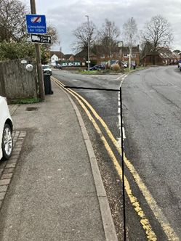 | 22.04.24 - The Parish Council was approached with concerns relating to this junction and a desire to:  - Provide a safer route for traffic coming over the Whetsted Road railway bridge and wanting to turn right towards Tonbridge  - Reduce the speed of traffic turning into Whetsted Road when coming from Tonbridge by making it a positive left turn.  - Improve the situations for buses turning at the village green when coming from Badsell Road  - Possibly reduce the use of Whetsted Road as a rat run when coming from the A228  ET explained that making Whetsted Road no entry at the start of the village green to direct traffic to turn left towards the shops would not solve the issue of cars travelling too fast from Five Oak Green Road onto Whetsted Road as that small stretch of road at the junction would effectively be one-way which is likely to increase speeds as drivers are confident that they will not meet on-coming traffic.  The Parish Council confirmed that the main issue is cars going too fast into Whetsted Road from the west. It is a very wide junction with no footways, but this section of road is used by pedestrians looking to cross to the green and the bus stop.  The Parish Council asked about a build out or planter at the junction. ET highlighted that there have been no injury collisions in the past three years involving cars pulling into/ out of either of the Whetsted Road/Five Oak Green Road junctions. As such, it would be difficult to justify the installation of any new street furniture here if a driver were to collide with it. There is also a national move to make the highway more passively safe.  However, ET agreed to arrange and fund some ATC speed surveys on both arms of the junction in the first instance and go from there (ATCs requested 26.04.24).  15.05.24 - Due to the layout of the road, the survey company is unable to lay a survey right at the junction of Whetsted Road with Five Oak Green Road. This is due to its proximity to the bend of the junction, making it unsafe for installation. However, they have proposed the below location for this arm of Whetsted Road and the tubes will be in place for seven days from 4 June 2024.  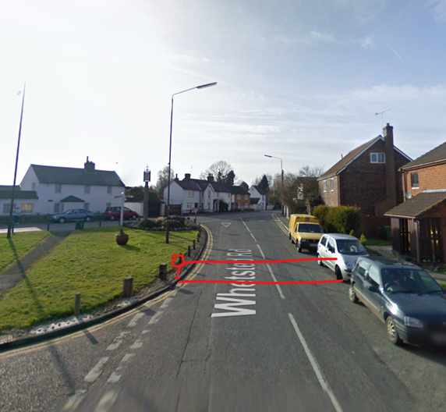  Regarding a traffic survey being carried out on the other arm of Whetsted Road, leading to its junction with the northern end of Badsell Road, the survey company have been unable to find a suitable location for installation as neither speed nor volumes would be accurately captured by the ATC counters due to the short length of the road.  ET updated the Parish Council and will let them know once we have received the survey data.  Update 01.07.24 - ATC results received and showed the following:  Eastbound - av. speeds 21.5mph/ 85% 26.9mph (no. of vehicles – 6871)  Westbound – av. speeds 16.9mph/ 85% 19.9mph (no. of vehicles – 5295)  ET updated the Parish Council but also passed to the Planning & Advice Team for their thoughts on what may or may not be possible at this location (on-going 02.08.24).
5. | New for 2024/25  Colts Hill Roundabout |  | Excessive speed of traffic turning left from Colts Hill on to Badsell Road | What can be done? | 22.04.24 - ET confirmed that KCC’s telematics speed data suggests average speeds when travelling north along Colts Hill and turning left to travel northwest along Badsell Road do not exceed high teens/ low 20s mph.  There have also been no collisions here in the past three years and there is already an advance direction sign on approach which indicates that there is a roundabout ahead.  Awaiting Parish Council’s comments on how they wish to proceed.  Update 02.08.24 - The Parish Council has requested that the size of the chevrons on the roundabout be reviewed, as they are concerned that they are too large, and that the signage on the approach to the roundabout from all four directions also be reviewed. ET passed to the Planning & Advice Team.
6. | New for 2024/25  Five Oak Green Road on approach to school from Tonbridge in vicinity of The George public house |  | Signage not clear as to when speed limit changes from 40mph to 30mph | Review signage | 22.04.24 - ET agreed to look into the possibility of enhancing the terminal signs below.  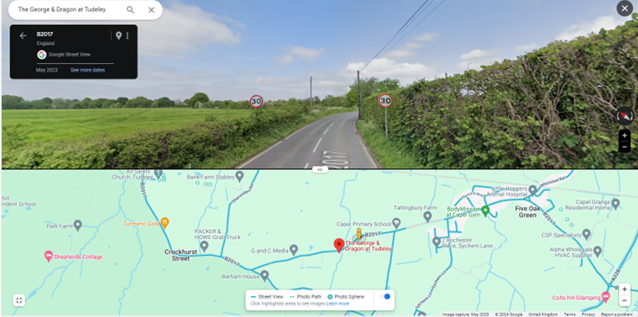  It may be possible to install 30 terminals on grey-backed signs so that they stand out from the vegetation and add a 30 roundel on the carriageway.  The Parish Council also asked if repeaters could be installed on this section of road before the system of street lighting.  26.04.24 - ET passed to Planning & Advice to review.  24.05.24 - As per Priority 5 “Five Oak Green Road in vicinity of Sychem Lane and the Primary School", KCC is happy to install a pair of 30mph repeaters (back-to-back), co-located with roundel markings on the carriageway on the unlit section of Five Oak Green Road between the 30mph gateway and the school.  With regard to the existing 30mph speed limit gateway, the developer has some proposals for this location which they are planning to meet with the Parish Council to discuss at the end of May/beginning of June.  05.06.24 - The Design & Delivery Team agree with the above proposal and KCC can fund up to three new 30 repeaters along this section of road. Between the existing terminal signs and the first streetlight it is roughly 350m. The DfT’s Traffic Signs Manual states that the max distance between the repeaters is 200m but we would recommend installing them at 100m spacings due to the road dynamic not changing until past the school.  Parish Council updated. Awaiting confirmation that they wish KCC to proceed as above.  Update 02.08.24 - The Parish Council has agreed that they would like KCC to progress with the proposed scheme above. ET passed to the Design & Delivery Team and will let the Parish Council know when the job has been passed to our contractors.

Historical Priorities Record
No | Location | Problem/Concern | What do you feel are the potential solutions? | KCC Comments
1. | Whetsted north junction A228 | Excessive speed on A228. High number of accidents recorded. Heavy vehicles joining fast moving road. Widening of the main carriage at the junction. Redesign of junction. | CRM Scheme installed in 2019. Site has not featured on cluster site list in years following and so no funding available for any further improvements.  KCC to request vegetation is inspected along the road to improve visibility. | Discontinued – maintenance issue in regard to vegetation
2. | Vicinity of Capel Primary School, Five Oak Green Road, Five Oak Green | Excessive speed when approaching the school. | Vehicle Activated Sign to provide a school warning sign from 08.30 to 09.30 and from 15.00 – 16.00, Monday to Friday.  Advisory 20mph sign installed | Installed end 2021.
3. | Badsell Road | Improvement to gateway on entrance to Five Oak Green | Gateway installed 2021 and paid for by Member Grant and Parish Council | Installed end 2021
4. | Whetsted Bridge, Five Oak Green | Existing signage is largely ineffective, large number of HGV vehicles rerouting though village. Prioritise additional signage. Implementation of weight and/or length limit. | KCC installed positive signage and lining scheme in Spring 2021 to direct traffic to A228. KCC agreed to re-assess late 2021/22 | Installed – no weight limits to bridge and brought forward into 2022 HIP.
5. | Junction Sychem Land/Five Oak Green Road and Ellis Close | Pedestrian crossing movements | To aid and formalise pedestrian crossing movements, a single chicane, located approximately 100 metres east of Sychem Lane proposed with a dropped kerb, tactile paving crossing facility within the village. This chicane has been chosen for crossing purposes as it is the most centrally located feature in relation to the village.  Additionally, a zebra crossing facility is proposed within the vicinity of the B2017 / Oak Road / Ellis Close crossroads to further aid pedestrian accessibility within the village. This is considered suitable with regard to the expected speed reduction within the village as a result of the chicane features, with both crossing locations provided with visibility splays of 2.4m by 43.0m in accordance with a 30mph speed limit. | Road not suitable for physical traffic calming at present as is classed as a B road and strategic route between Tonbridge and Paddock Wood.  Agreed that work to be undertaken on other measures in the HIP to see what impact this has and revisit this at another time.
6. | Whetsted Bridge, Five Oak Green | It can be very difficult for long or large vehicles to use and when long or large vehicles attempt to use the bridge it nearly always ends up with damage to the bridge or a vehicle accident. This is causing safety concerns to local residents who fear a lorry could end up shedding its load or even falling itself onto the railway below. | Introduce a weight limit but also due to the tight corner on the north side of the bridge a length limit | Pre-2023 - Check bridge for a weight limit – email structures. Is weight limit required for structural purposes. No weight limit on this bridge as discussed with Parish. Advisory ‘unsuitable for HGV’ signs have been installed.  No change. Lorry Watch given as alternative for parish to join and look into. Freight@kent.gov.uk  Fiona Paine and Capel Parish Council in September 2019 after which Fiona suggested KCC would not pursue an environmental limit.  KCC installed positive signage and lining scheme in Spring 2021 to direct traffic to A228. Allow scheme to bed in and assess impact later in 21/22.  18.01.23 - The Parish Council confirmed that there have been less reports of HGVs using the bridge due to the newly installed signage, but they still have concerns due to the age of the bridge and damage caused when HGVs ignore the signage as HGVs get stuck and have to reverse out. There is also no footway so is dangerous for pedestrians.  PC requested KCC to look into possible solutions such as making the bridge one-way (with a barriered footway on one side) or installing a length limit due to the length of lorries using the bridge and the tight corner.  01.02.23 - ET has emailed the Structures Team for advice regarding the length limit and has asked Planning & Advice (ref. 12409015) to look into the one-way suggestion.  20.03.23 - The Planning & Advice team has completed their review. See separate document titled “Planning & Advice response to Whetsted bridge, Five Oak Green, Tonbridge”.  Update 19.04.23 - The Structures Team has confirmed that the bridge is owned by Network Rail and they are satisfied that there is no issue with standard road vehicles using the bridge. They have no concerns regarding any damage or frequency of which it occurs. The Farm manager has also confirmed that his vehicles do not go that way and the signage around his farm backs up that theory. NFA from HIT.
7. | Junction Alders Road and Colts Hill A228 | Speed and volume of traffic. | Left turn only when exiting Alders Road and no right turn into Crittenden Road (staggered crossroad). This is a CRM site. | Pre-2023 - This has moved forward – proposal for future as development for Colt’s Hill bypass. As part of this, location will be changed to a roundabout. Louise Gordon she is principal planner. Parish didn’t like sound of plans and conversation was halted at this point.  18.01.23 - The above scheme is part of the TWL local plan which will not be approved in the near future so the issues here will not be addressed any time soon.  01.02.23 - ET has requested information from the wider WK HIT team to understand the background at this location and will investigate if there is anything that can be done here in the meantime as the PC believe this junction to be very dangerous and difficult to navigate.  Update 02.02.23 - A scheme was previously considered to the widen road to put in a right turn lane, but this requires private land which is earmarked for a by-pass and a roundabout at this junction.  This scheme would also only be as good as enforcement and vehicles are likely to turn further down the road at inappropriate places which could be more dangerous.  Everything that we can do here (outside of a large costly scheme (min £500k), requiring land) has been done and we are unable to prioritise this for funding with the proposals that are part of the local plan. There is also an issue with loss of trees and the fact that the landowner would have to give up land for free, which they are unlikely to do with the possibility of funding from developers for the same land. NFA for HIT.
8. | Five Oak Green Road/ Alders Road |  |  | 18.01.23 - This was originally on the HIP but was removed as the PC was told that work was planned for the turning at the jct of Five Oak Green Road/ Alders Road as part of a CRM scheme.  One chevron has been installed but the PC were expecting two chevrons and white lines to be installed.  01.02.23 - ET has requested information from the wider WK HIT team to find out if any further works are taking place at this location.  Update 02.02.23 - When this was originally reviewed by the team, it was explained to the Parish Council that only one chevron would be installed. In addition, and as per Chapter 5 of the Traffic Signs manual, this location does not meet the criteria for stop markings (very few places meet the criteria and stop markings must only be used in exceptional circumstances).  With regard to a second chevron, there is no space to install this. There is a requirement of 1.2m from the edge of the carriageway to the start of a sign when installed on a 50mph+ road so the available verge would need to be ap. 4m. There is no room at the jct. and we do not own the land here. We also need to consider the visibility for those leaving Alders Road and the driveway on the corner should a chevron be installed. NFA for HIT.
9. | Various locations throughout the parish – as above and Badsell Road. | Excessive speed. | Three average speed cameras in the parish. KCC meant to have sent a request to Kent & Medway Safety Camera Partnership to contact parish council | Pre 2023 - Telematic data show speeds between 25 – 35mph. ATC to determine true speed however its within enforcement threshold so AVG speed cameras will not be accepted at this location  Update 18.01.23 - Parish Council has been provided with the following ATC results:  Badsell Road (30mph) – average speeds 30/31mph (85% 34-37mph).  There is a tight bend as you enter the village with no visibility and lack of footway. There have been near misses that have been reported to TWBC via their near miss register.  01.02.23 - ET has asked Planning & Advice (ref. 12409016) to consider what could be done on Badsell Road to reduce speeds and make this road safer (ET suggested possible SID location 13.03.23 - see comments under Priority 2 ‘Vicinity of Capel Primary School, Five Oak Green Road, Five Oak Green’.).  With regard to the near miss register, we have had multiple discussions with TWBC about this and have informed them that we have our own methods of communication where customers can raise concerns. We understand that TWBC wish to use the register for their own plan for what they want done on the highway, however we will only follow up on concerns raised via the normal channels (e.g. HIPs, customer enquiries, planning permission etc). If the Parish Council has the details of near misses reported to TWBC they are welcome to send these on to KCC directly.  20.03.23 - The Planning & Advice team has completed their review. See separate document titled “Planning & Advice response to Badsell Road”. Parish Council to confirm if they are happy to pursue the installation of a SID as a possible solution for this location.  Update 28.04.23 - Re. SID scheme, see comments under Priority 2 ‘Vicinity of Capel Primary School, Five Oak Green Road, Five Oak Green’.
10. | Vicinity of Capel Primary School, Five Oak Green Road, Five Oak Green | Excessive speed when approaching the school. | Painted signage on the road within vicinity of the primary school to reinforce the 30mph speed limit throughout the village. | Pre-2023 - Advisory 20 recently installed and with roundels maybe seen as a confusion although 20 is advisory. Area not street lit. ATC to ascertain new issues if one has arisen.  Maybe upgrade signage- look at signage in this area – if this is something the Parish would prioritise.  18.01.23 - Parish Council has been provided with the following ATC results:  Five Oak Green Road - average speeds between 32-33mph (85% 38/39mph)  Parish Council has raised concerns around speeds being quicker outside of school time due to parked cars at drop off and pick up slowing traffic down, but conversely these parked cars are causing vehicles, including HGVs, to mount the footway resulting in near misses and the death of several dogs.  The PC previously had a VAS but this was hit by a lorry and they have been told that this cannot be replaced. ET to discuss details with the team responsible around the reasons for no replacement, insurance, why the criteria has changed (not safety critical) and why the PC no longer meets the criteria.  We briefly discussed SIDs as a possible alternative solution.  01.02.23 - ET emailed the Traffic Operations & Technology Manager for further information, who has provided the following information:  - The criteria for the use of such signs is that they are a last resort option after all other engineering measures have been tried. They are not statutory, not safety critical and non-enforceable. Even if a funding source is available, a full re-assessment of the site/need must be undertaken. The over-saturation of this electronic devices has undermined their overall effectiveness and is the reason the criteria changed. The two in Five Oak Green (both removed) were installed long before this and will not be automatically replaced as there is no budget for them.  - In terms of insurance, we would seek to recover costs from a third party and this was hit by an unknown HGV. There is no possibility of any insurance claim – which would only ever be successful if we replaced the sign first (which we are unable to do as outlined above). All highway assets are not covered by insurance, so we effectively self-insure, i.e. if it gets broken, we pay from our existing budgets where funding is available, and it meets the criteria for replacement.  - SIDs are a possibility. The Parish Council will have to provide a minimum of three locations, suggested by them and agreed by us, then be moved around by local volunteers. They can only be used in 30 mph zones and the team can liaise with the Parish directly if this of interest. These will need to be funded by the Parish Council and added to their insurance in the event of damage.  01.03.23 - Parish Council confirmed that they would like to pursue the installation of SIDs. ET requested locations and provided PC with criteria.  13.03.23 - Parish Council queried SID locations. ET suggested looking at Five Oak Green Road, Whetsted Road and Badsell Road as these are 30mph that the PC has previously raised concerns about. Once we have an indication of potential sites where speeding is of the most concern, a site review will be carried out to confirm suitability.  20.03.23 - ET emailed the Traffic Operations & Technology Team to request that they make contact with the Parish Council regarding moving forward with the SID scheme (chased 25.04.23). Possible locations have been provided as follows but the team will advise on suitability and will be able to discuss the potential for further sites within the Parish.  - Five Oak Green Road – location of the VAS  - Whetsted Road – between the start of the 30mph to where the houses are set back from the road, just before the bridge. Looking at the telematics data, this is where the average speeds are the highest. We only own some of the verge along this section of road so there may be some limitations but that would be picked up as part of the site assessment.  - Badsell Road – between the start of the 30mph, just past Capel United Church, to just before the turn off to the Village Hall. This is where the average speeds seem to be at their highest.  28.04.23 - Parish Council were emailed by ITS Project Manager with the outcome of their SID site review. They found only two of the identified locations to be suitable for a SID (Five Oak Green Road & Badsell Road), and a minimum of three are required. They attempted to find alternative locations within the 30mph areas but were extremely constrained in identifying suitable safe positions. Based on the locations provided, we are unable to accommodate a SID scheme for Capel.  03.05.23 - ET meeting with Capel PC 11.05.23 to discuss this further.  12.05.23 - On site, the Parish Council and KCC discussed the possibility of installing a SID on the grass verge just past Capel Primary School on Five Oak Green Road, at its junction with Church Lane. This has been passed onto the Traffic Operations & Technology Team to assess as a possible third location.  15.05.23 - SID location request form sent to the Parish Council to complete and return to ET, relating to Five Oak Green Road at the junction with Church Lane, to assist the Traffic Operations & Technology Team with their assessment.  26.05.23 - SID location request form has been completed by the Parish Council and sent to the Traffic Operations & Technology Team for their comment/ approval of the three locations proposed.  05.07.23 - Five Oak Green Road, nr Primary School, and Badsell Road locations have been approved for SIDs. Query re land ownership of verge at the second location on Five Oak Green Road, nr to the junction with Larkfield. ET sent an enquiry to Highway Definitions to confirm the highway boundary ref. 12409461.  05.09.23 - The Highway Definitions Team have confirmed that KCC is responsible for the verge at the second location on Five Oak Green Road, nr to the junction with Larkfield. As a result, the Traffic Operations & Technology Team are happy to proceed with the three proposed locations on Five Oak Green Road and Badsell Road.  ET has sent the Parish Council two quotes for the two sign types available, the MINI and the ADVANCED.  Parish Council to undertake an informal consultation with residents regarding the signs and locations. The Traffic Operations & Technology Team would need to be provided with a copy of the consultation plus any feedback received once the consultation has concluded (Parish Council started the consultation process w/c 25.09.23 and hope to send the results to KCC w/c 09.10.23).  Provided that the consultation does not result in any negative feedback that can’t be overcome, and once the sign type is agreed and paid for, the order can then be placed.  23.11.23 - Capel Parish Council has sent in the results of their engagement with residents regarding the proposed SID scheme for Five Oak Green and ET has sent the results of their survey onto The Traffic Operations & Technology Team. The results demonstrate that 93% of respondents support the proposal.  At their next Parish Council meeting on Monday 27th the Parish Council will be deciding which type of SID to purchase but ET has informed the Traffic Operations & Technology Team that, regardless, they would like the facility for data collection to allow downloading to a spreadsheet via Bluetooth.  28.11.23 - The Parish Council confirmed that they would like to go ahead with the MINI SID scheme. ET has submitted an invoice request for £9513.22 and will request that the Traffic Operations & Technology Team places the order for the SIDs as soon as payment is received.  07.12.23 - Payment received from Capel Parish Council. Traffic Operations & Technology Team informed and order placed. The lead time for installation and handover is quoted at 10-12 weeks, subject to emergency works. ET has informed the Parish Council and will keep them up to date if anything changes.  06.03.24 - ET confirmed to the Parish Council that the Traffic Operations Team have now received the full kit and they will be charging up the batteries and contacting the Parish Clerk to arrange a handover time and date shortly.  07.03.24 - The Traffic Operations Team has made contact with Capel Parish Council directly to arrange delivery, handover and demonstration of the SID. This has been proposed for 15 March 24.  Update 15.03.24 - Parish Council are now in possession of their SID. NFA for HIT.
11. | New for 2024/25  Castle Hill (development on the Tunbridge Wells side of the A21) | Prevention of further encampments | Install posts on KCC owned land | 22.04.24 - The Parish Council informed ET that KCC’s Gypsy and Traveller unit were recently involved in moving an encampment on from here.  26.04.24 - ET has emailed the Gypsy and Traveller unit to discuss and will keep the Parish Council updated.  Update 15.05.24 - ET has heard back from KCC’s Gypsy and Traveller Unit who confirmed that they, along with Kent Police, had involvement in the removal of an encampment at this location due to the behaviour of the occupants but they do not have any further involvement with regard to preventative measures. Having spoken to the Senior Highway Manager, responsible for the maintenance of highway assets, such as bollards etc., they confirmed that they will not support the installation of bollards at this location. This is predominantly because preventive measures, such as bollards, have been installed at similar sites in the past and these are consistently damaged and removed regardless of how heavy duty they may be. The Maintenance team does not have the budget to continue to replace them and we would therefore be unable to pursue this request through the HIP process.  ET updated the Parish Council and reminded them that any unauthorised encampments can be reported on-line at Report an unauthorised Gypsy and Traveller site - Kent County Council so that the Gypsy and Traveller Unit can take action accordingly.  NFA for HIT.
12. | New for 2024/25  Five Oak Green Road in vicinity of Sychem Lane and the Primary School | Motorists not adhering to the 30mph speed limit | Repeater 30mph signs and roundels required. | 22.04.24 - ET noted on site that it is not possible to install roundels and repeaters where a road is 30mph by virtue of streetlighting. Section 82 of the Road Traffic Regulation Act 1984 defines a road that has a system of street lighting as being a restricted road. The presence of lighting therefore means that a road automatically has a speed limit of 30mph with the lamps taking the place of repeater signs and KCC is prohibited from erecting 30mph repeater signs.  However, the Parish Council queried if the street lighting outside the school constitutes a series of street lighting. ET to refer to Planning & Advice and feedback to the Parish Council (done 26.04.24).  In the meantime, Capel does have their new SID scheme at either end of this stretch to remind drivers of the 30mph.  In addition, programmable flashing school wig wags with advisory 20mph plate have been installed (awaiting programming) by KCC along this stretch of road which should help with reducing speeds past the school during the morning and afternoon peaks.  Update 24.05.24 - KCC’s Planning & Advice Team has confirmed that the street lighting outside the school and along to Sychem Lane does constitute a system as per the TSRGD (Traffic Signs and Regulations and General Directions), as the lamp columns are spaced less than 183 metres apart (approx. 101m, 92m, 105m and 95m).  However, chapter 3 of the DfT’s Traffic Signs Manual (TSM) does recommend that a 30mph repeater should be provided for the unlit section no more than 100m from the last streetlight and KCC would be happy to arrange this as per Priority 7 “Five Oak Green Road on approach to school from Tonbridge in vicinity of The George public house”.  Parish Council updated 05.06.24.

